**LAPORAN TUGAS SYNCHRONOUS 3**

Untuk Memenuhi Tugas Synchronous 3

SQL Query – Query Practice



Mentor :

**Rusnanda Farhan**

Disusun oleh :

Nadiyah Qasamah

4522210046

**DATA SCIENCE BASIC**

**CELERATES ACCELERATION**

**PROGRAM**

**2024**

**Hal 9 : Database Pagila**

1. Show all fields and records from the staff table

**select** * **from** staff *s*;

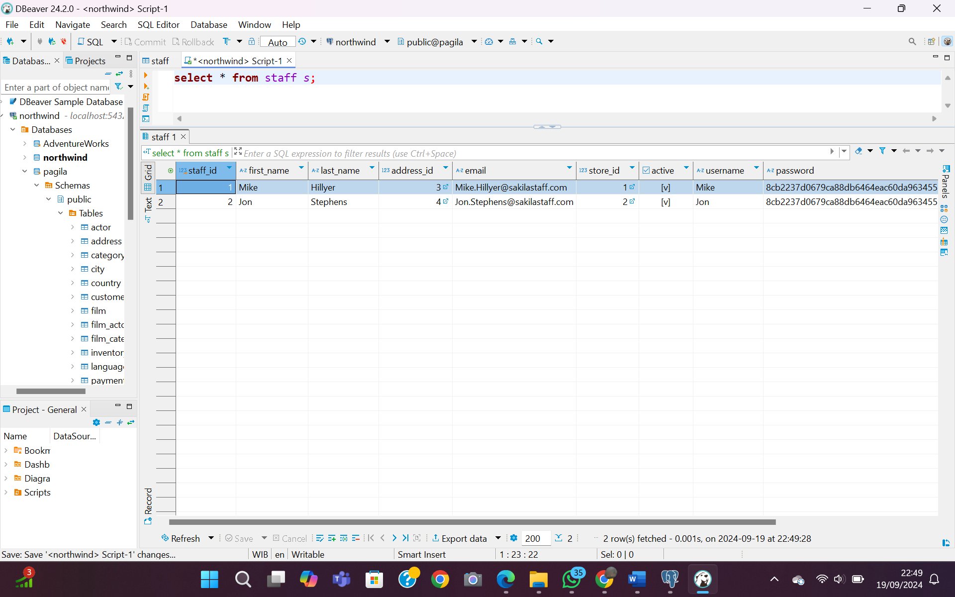

1. Show address and district columns from address table

**select** address,district **from** address *a*;

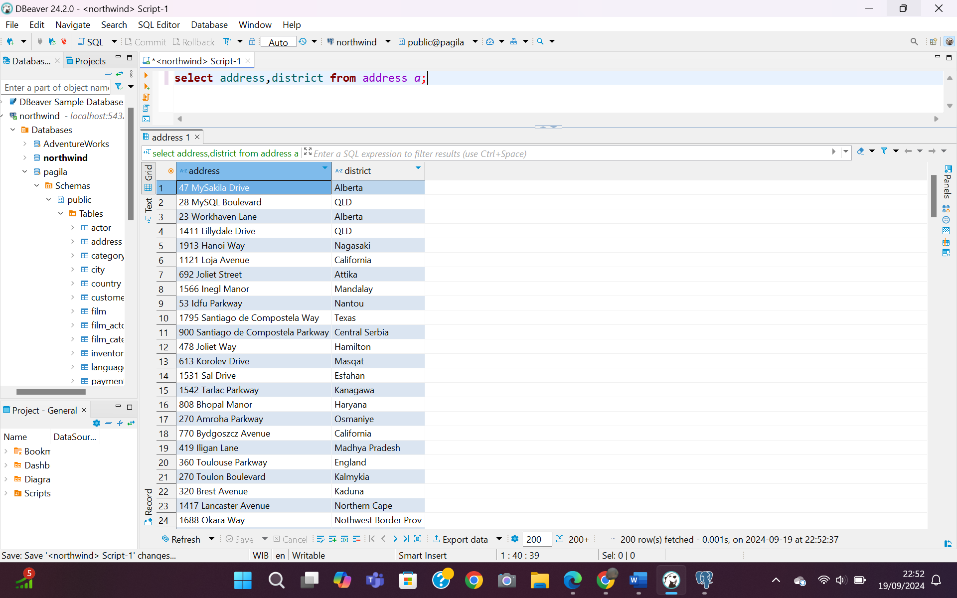

1. Show all the distinct last names from customer table

**select** last_name **from** customer *c*;

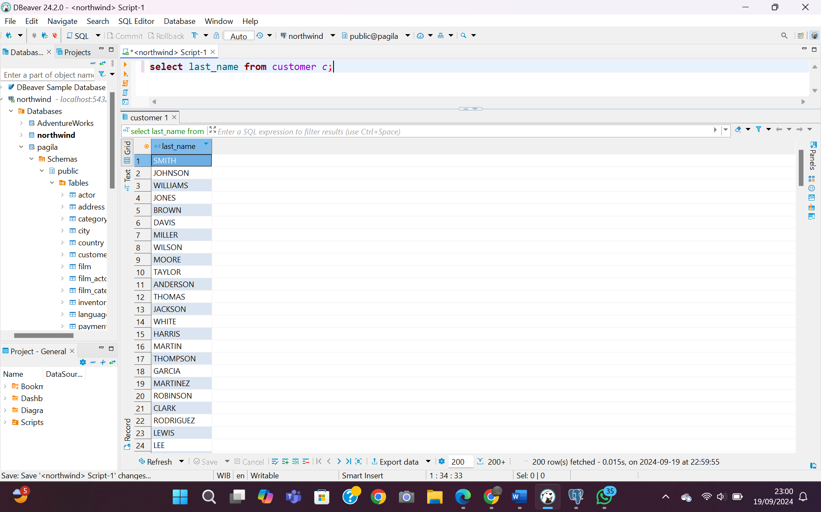

1. Find the number of films

**select** **count**(film_id) **from** film *f*;

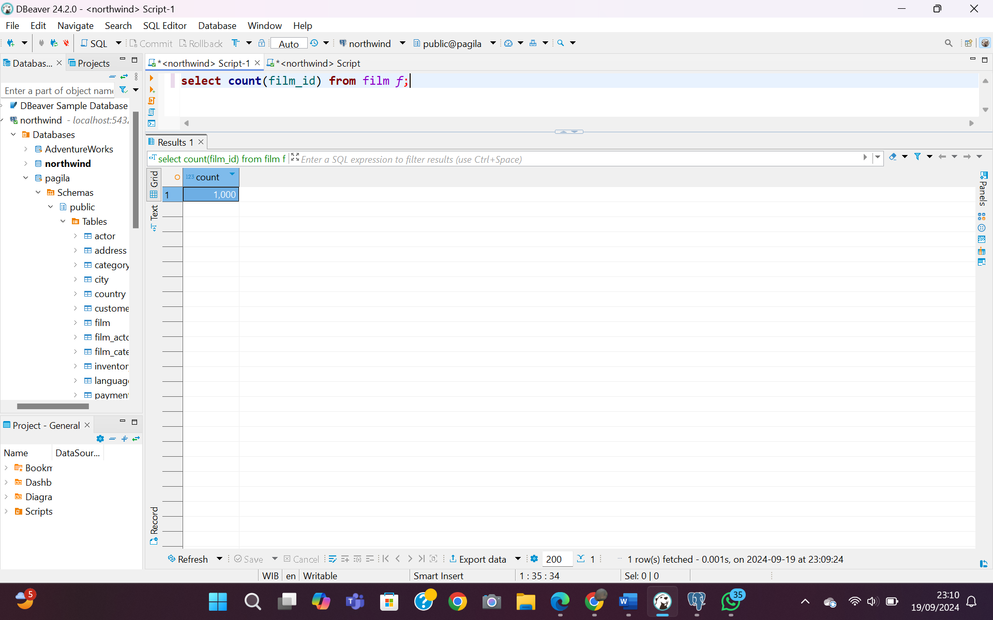

1. Find the number of distinct first names in actor table

**select** **count** (**distinct** first_name) **from** actor *a*;

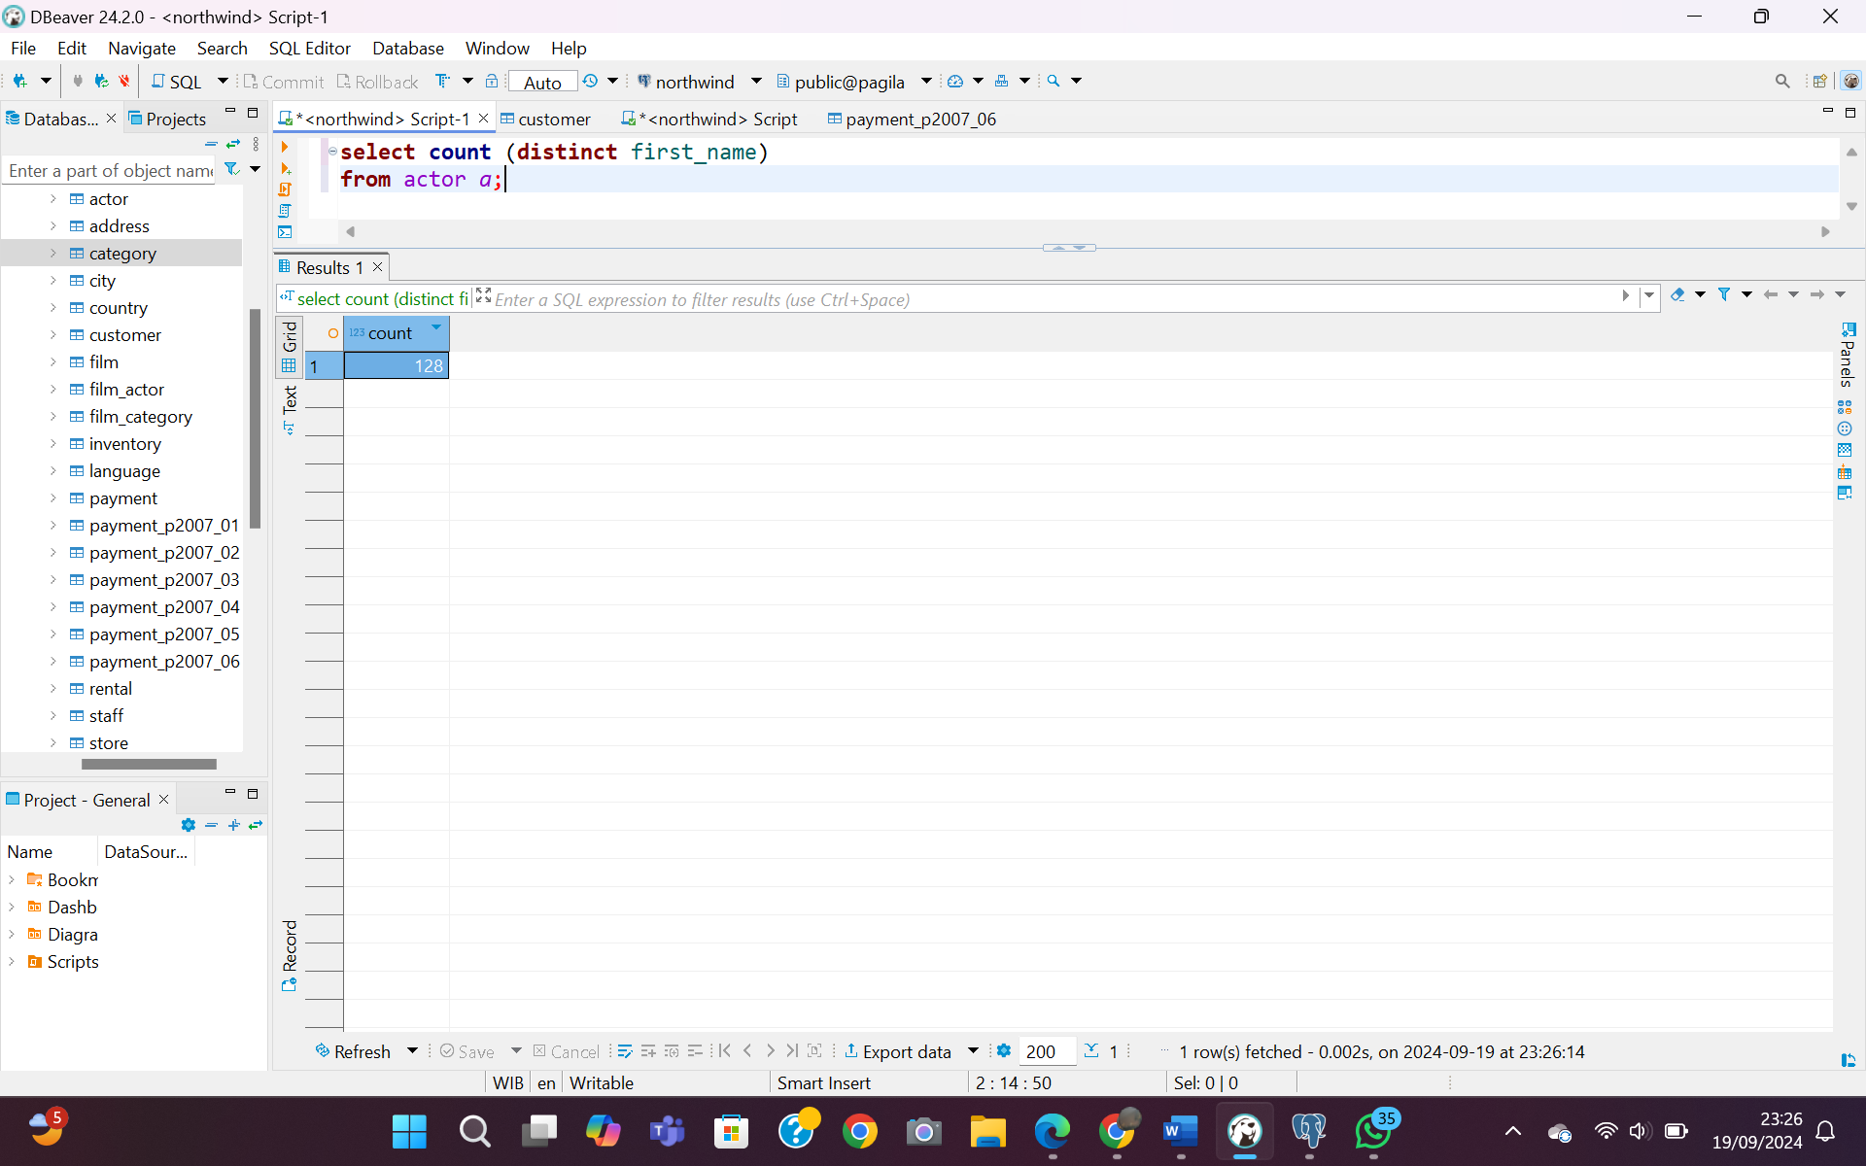

1. Show the data rental_id and the difference between return_date and rental_date in rental table

**select** rental_id, (return_date-rental_date) **as** *selisih* **from** rental *r*;

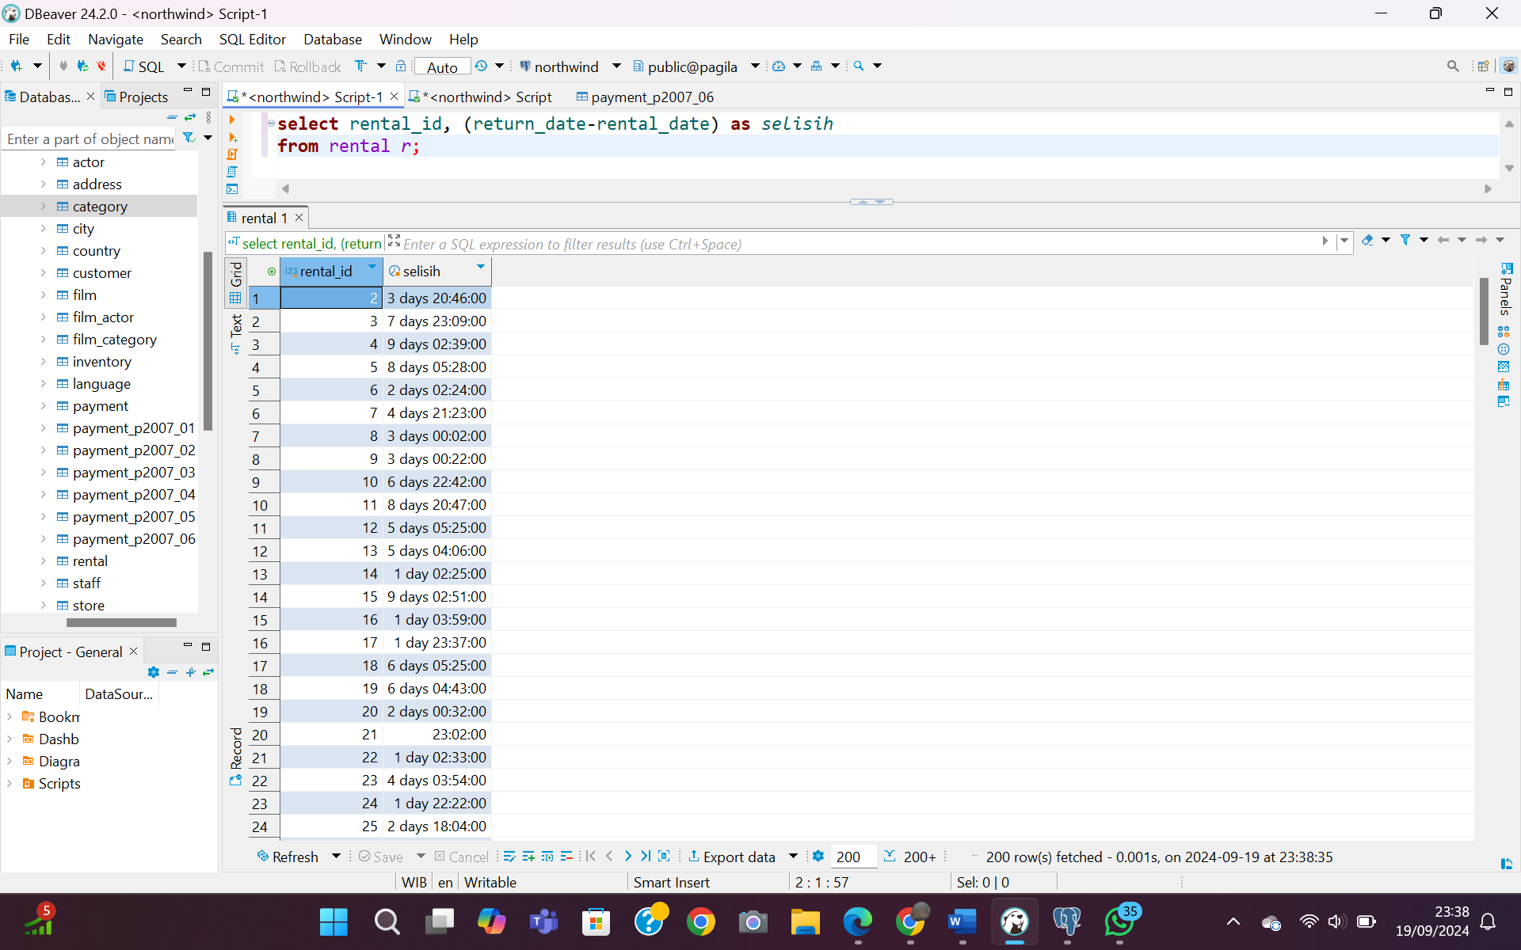

**Hal 17 : Database Usda**

1. Select all records from data_src which came from the journal named ‘Food Chemistry’ **select** * **from** data_src *d* **where** journal = **'Food Chemistry'**;

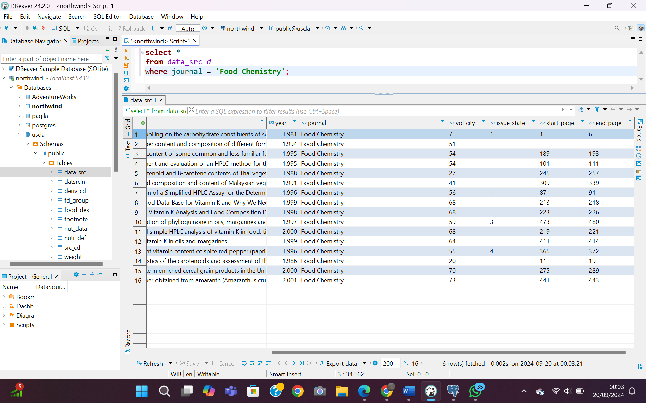

1. Find all the food descriptions (food_des) records for manufacturer Kellogg, Co. (must include punctuation for exact match)

**SELECT** manufacname **FROM** food_des *fd* **WHERE** manufacname = **'Kellogg, Co.'**;

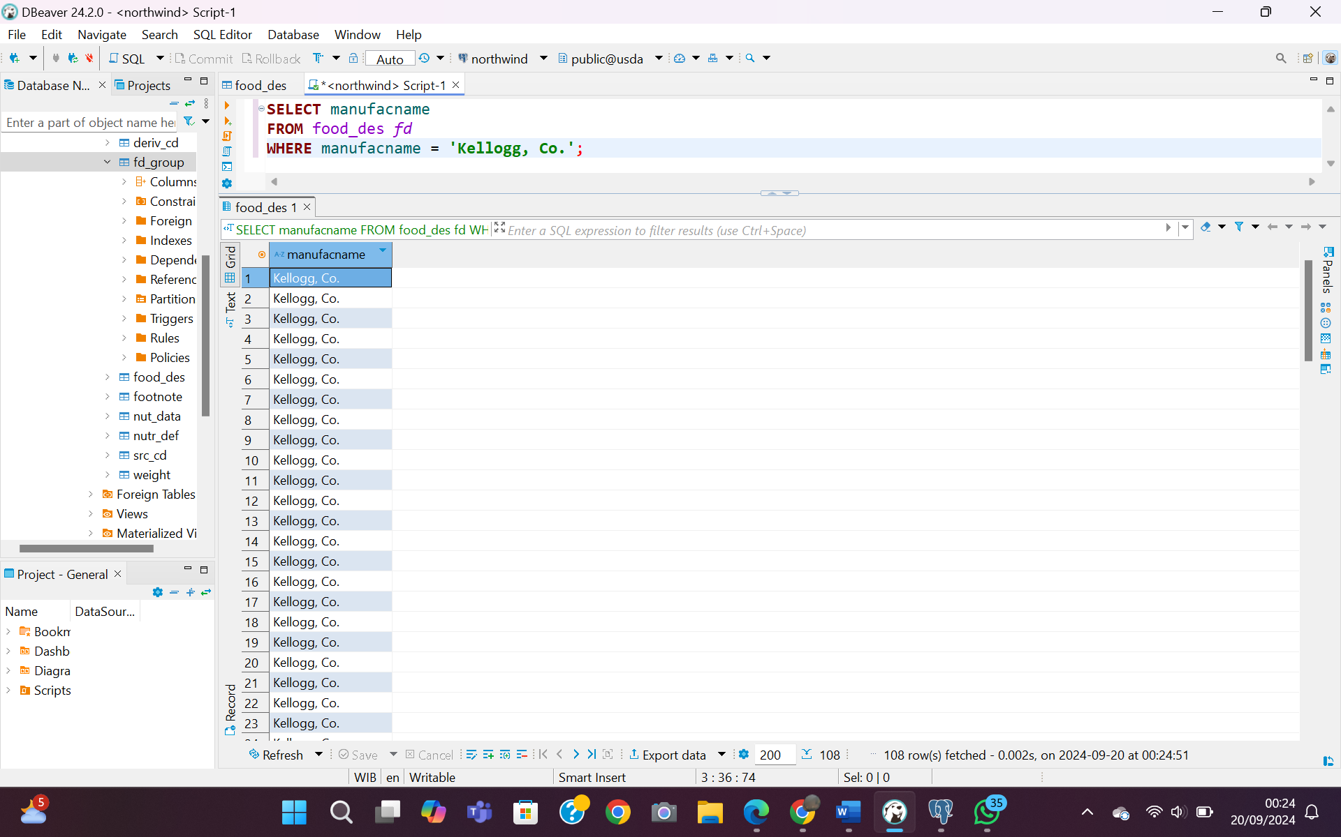

1. Find the number of records in data sources (data_src) that were published after year 2000 (it is numeric field)

**select** **count**("year") **from** data_src *ds* **where** "year" > 2000;

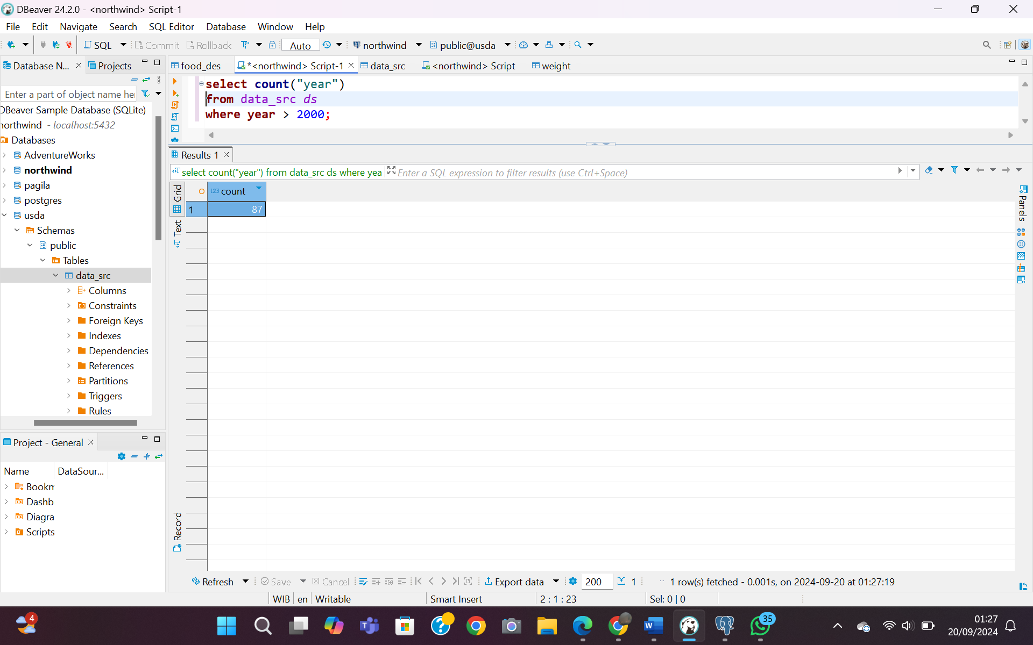

1. Find the number of records in food description table that have pro_factor greater than 1.5 and fat_factor less than 5

**select** **count** (*) **from** food_des *fd* **where** pro_factor > 1.5 **AND** fat_factor < 5;

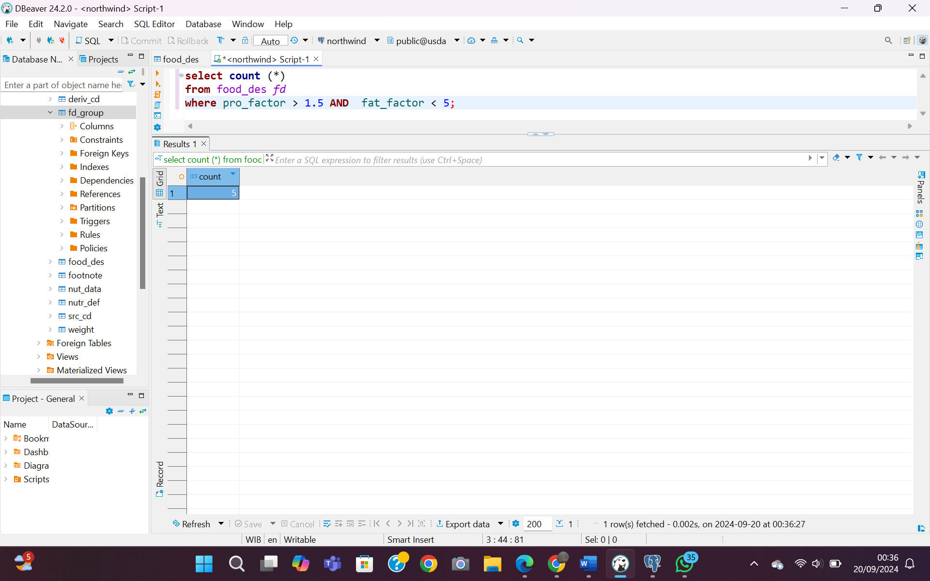

1. Find the record in data source table that is from year 1990 and the journal Cereal Foods World

**select** "year", journal**from** data_src *ds***where** "year" = 1990 **and** journal = **'Cereal Foods World'**;

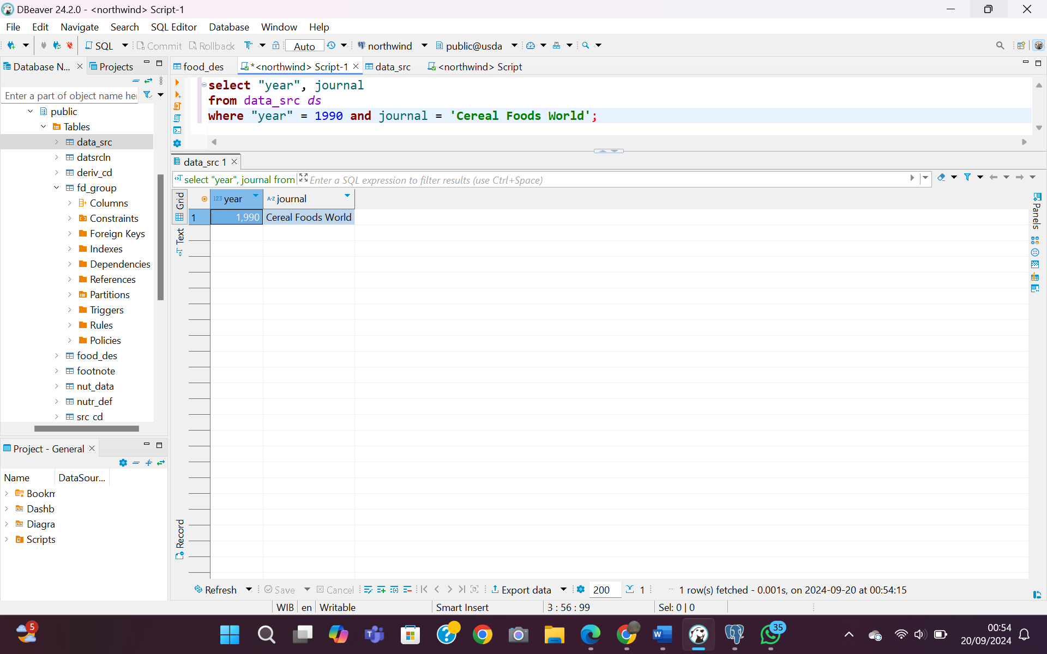

1. Select the records in nutr_def table (nutrition definitions) that have units of kj of kcal

**select** units **from** nutr_def *nd* **where** units = **'kj'** **or** units = **'kcal'**;

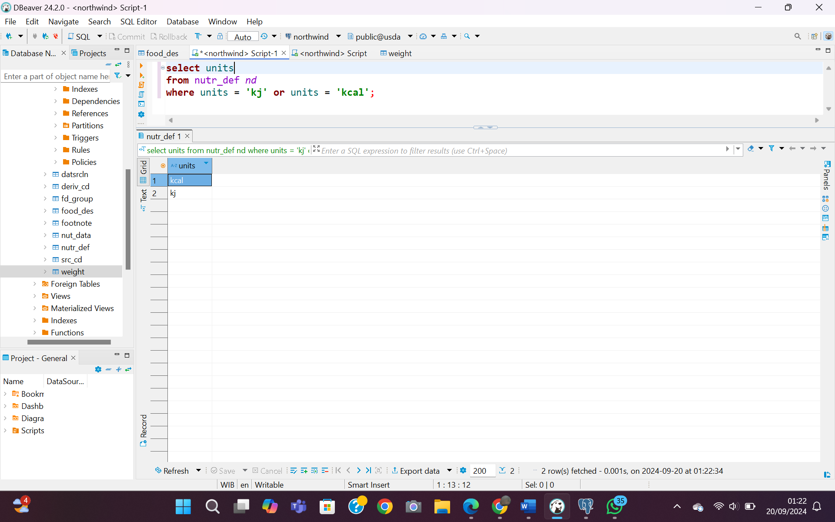

1. Select all records from data source table (data_src) that where from the year 2000 or the journal Food Chemistry

**select** "year",journal **from** data_src *ds* **where** "year" = 2000 **or** journal = **'Food Chemistry'**;

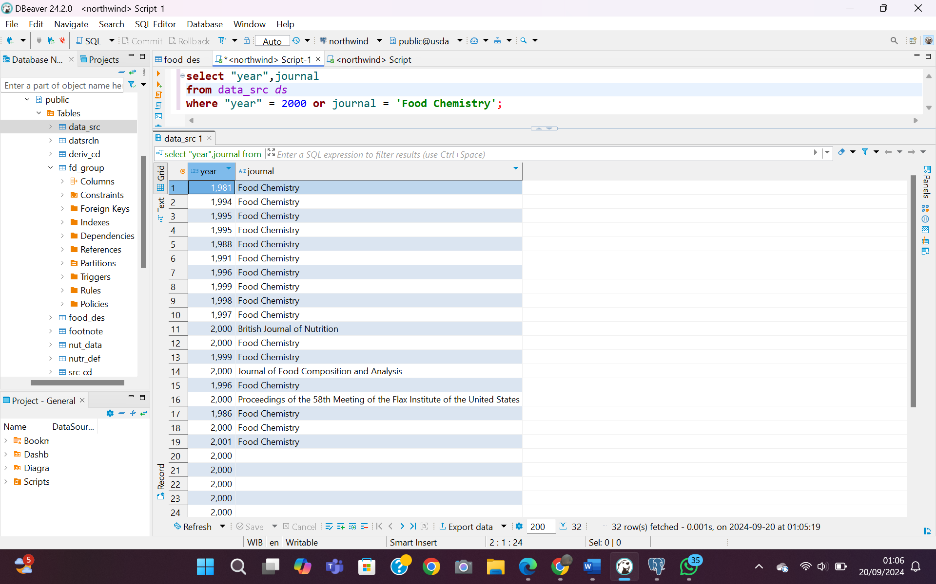

1. Find all the records in data sources that where between 1990 and 2000 and either ‘J. Food Protection’ or ‘Food Chemistry’

**select** "year", journal **from** data_src *ds***where** "year" **between** 1990 **and** 2000 **and** (journal = **'J.Food Protection'** **or** journal = **'Food Chemistry'**);

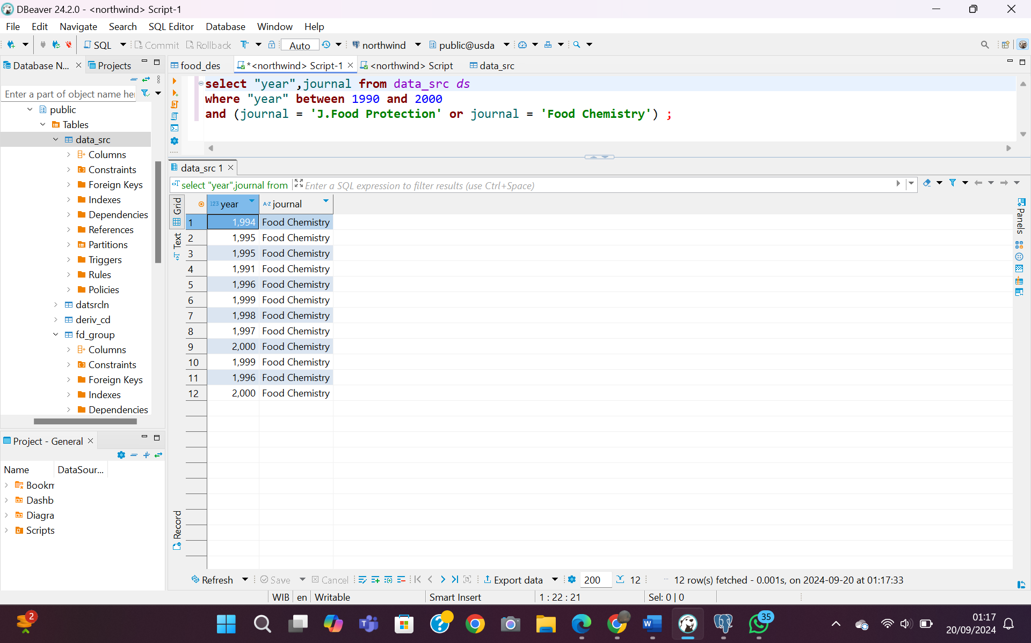

1. Use BETWEEN syntax to find number of weight records that weight between 50 and 75 grams (gm_wgt)

**select** gm_wgt **from** weight *w* **where** gm_wgt **between** 50 **and** 75;

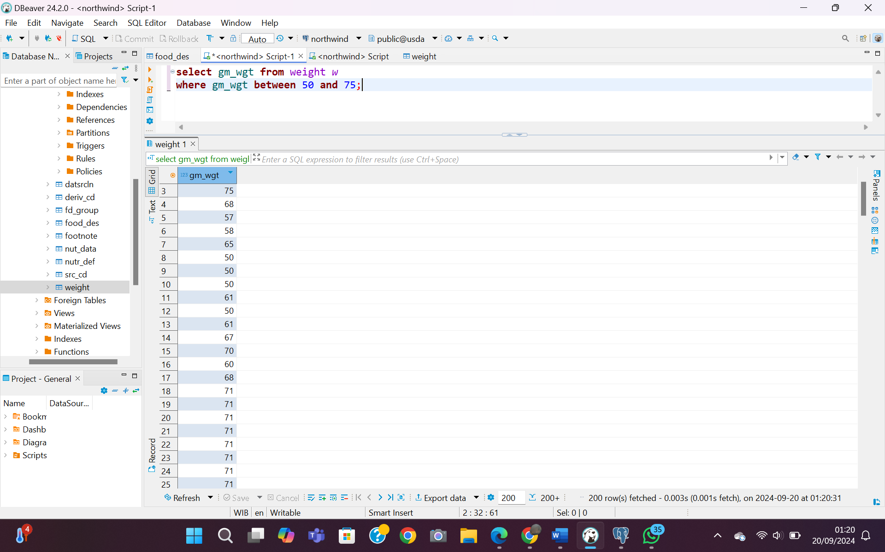

1. Select all records from the data source table that were published in years 1960, 1970, 1980, 1990 and 2000. Use the IN syntax

**select** "year" **from** data_src *ds* **where** "year" **IN** (1960, 1970, 1980, 2000)

